# Multi Agent Systems - Question 3

* 1. The query we used to find the grounded set is ‘grounded(X).’ where X is bound the result in the form of (claim, [argument]) and the grounded set is:

X = (free6pm_a, [free6pm_a])

X = (free6pm_b, [free6pm_b])

X = (free8am_b, [free8am_b])

X = (child_a, [child_a])

X = (overweight_b, [overweight_b])

X = (not_get8am_a, [not_get8am_a])

X = (not_get6pm_b, [not_get6pm_b])

X = (not_get8am_b, [not_get8am_b])

X = (get6pm_a, [free6pm_a, not_get8am_a, not_get6pm_b])

X = (get8am_b, [free8am_b, not_get6pm_b, not_get8am_a])

X = (not_free8am_a, [child_a])

X = (not_sports_b, [overweight_b])

Therefore we can see that free6pm(b) belongs to the grounded extension.

* 1. SXDD confirms that free6pm(b) belongs to the grounded extension.

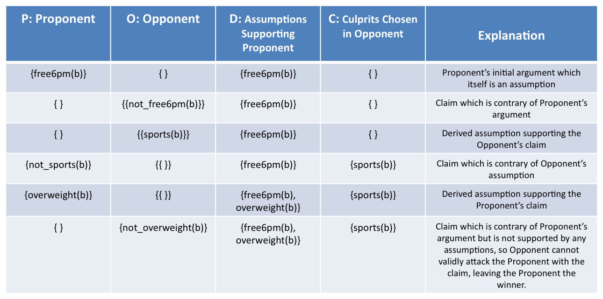The table below shows the AB dispute table for free6pm(b). The next page shows the dispute in diagrammatic form.

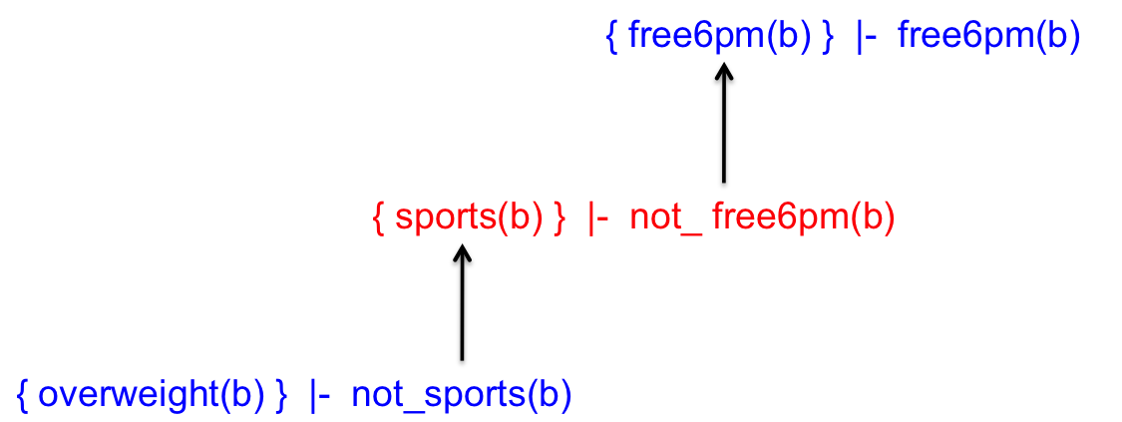

* 1. Looking at our results (and using proxdd) we have confirmed that free8am(b), free6pm(a) and free6pm(b) all belong to the grounded set. This means that free8am(a) does not belong to the grounded set.

In addition, we see that get6pm(a) and get8am(b) is in the grounded set and therefore we can say that Anne (a) will get the 6pm appointment and Boris (b) will get the 8am appointment.

For stable semantics,